**ТЗ сайта Provizio**

Цветовая гамма (голубой, черный, белый — как в презентации).

Лого в шапке слева.

Основной баннер — фото с бабулей. Поверх фото текст **Digitizing sight care**

Разделы сайта (они же кнопки в шапке сайта) — **Home, Solution, About us, Our team, Contact us**

**Home –** нажатие переводит в шапку сайта

**About us** -

*Who we are*

First and foremost, true fans of the Internet of Things! We truly believe that in the nearest future every consumer and medical device will be connected to a smartphone. That’s why we decided to dedicate ourselves to the world of IoT to hasten that day. Our team consists of superstar engineers obsessed with Bluetooth technology which we have explored inside out.

*What we do*

Develop sophisticated medical devices from scratch. Create mobile apps and firmware that control wearable and embedded devices with the help of Bluetooth and Bluetooth LE. Transform medical sector by personalizing healthcare diagnostics and treatment.

**Home**

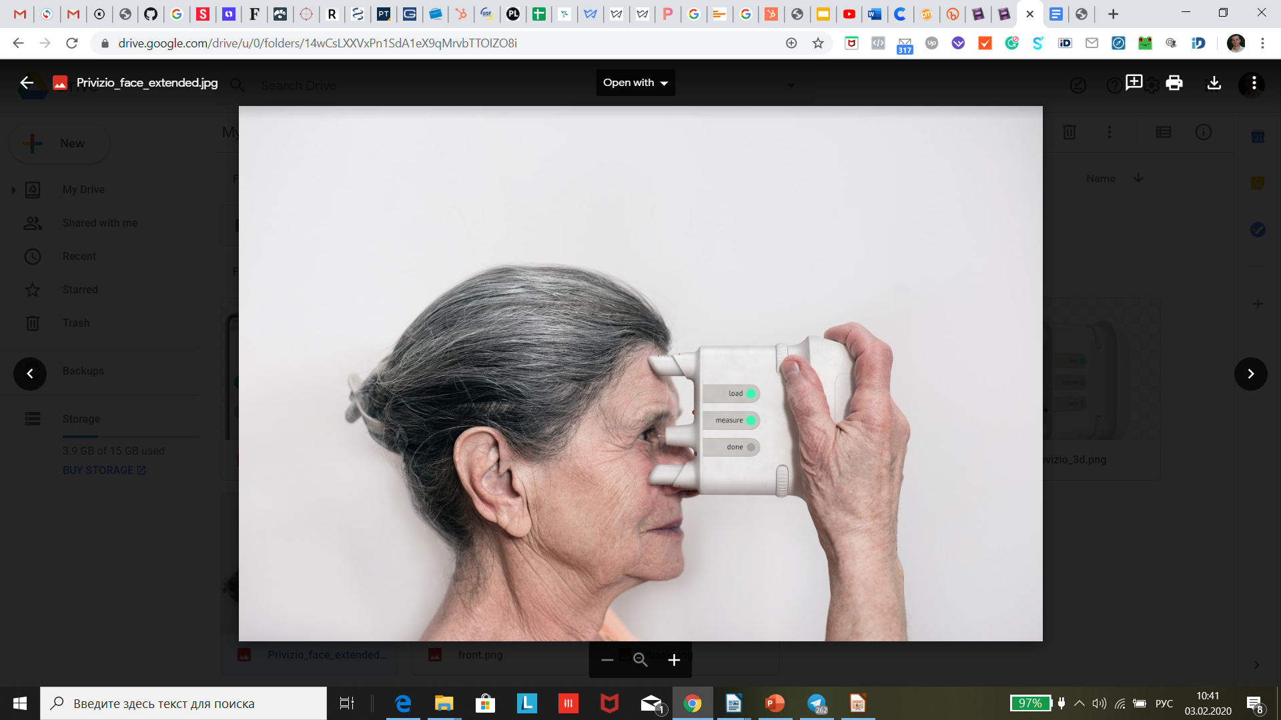

**Digitizing sight care**

**Solution** -

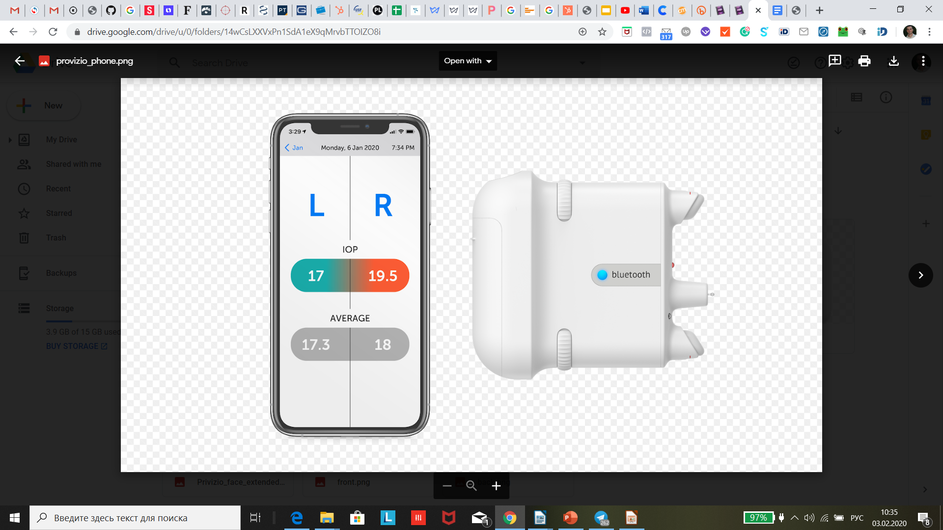PROVIZIO is a wireless intraocular pressure measurement system for glaucoma patients home monitoring.

An average glaucoma patient makes visits to his doctor every 6 months. Between the visits patient has no idea about his daily intraocular pressure numbers, they can increase and lead to a serious vision field loss in just couple of weeks or even days.

It is of high importance to be able to monitor glaucoma patients every day, keeping their pressure under control and changing their therapy quickly when needed.



